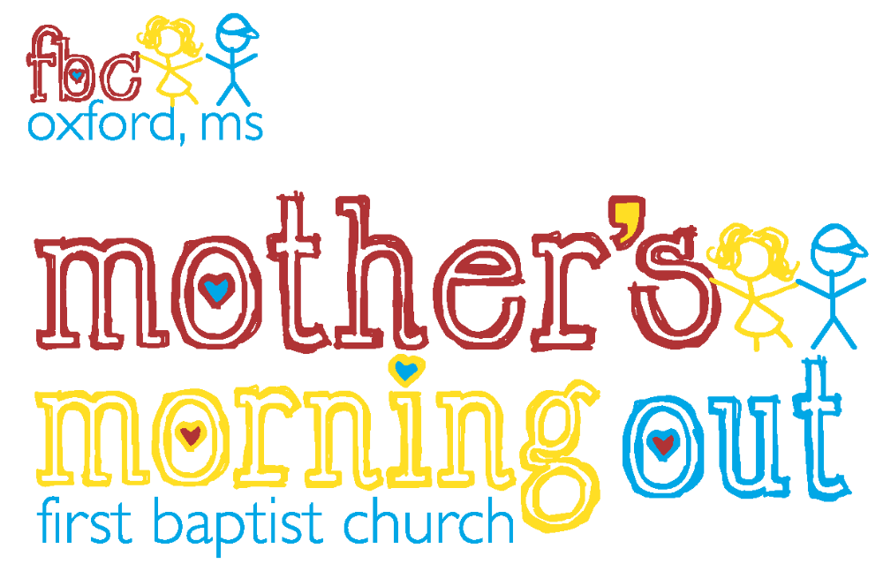

Student Handbook

* * *
First Baptist Church
Mother’s Morning Out

Ministry of
First Baptist Church
800 Van Buren Avenue
Oxford, Mississippi
Student Handbook Contents

Page

Overview of the Mother’s Morning Out Program . . . . . . . . . . . . . . . . . . . . . . . . . . . . . . . . 3
Vision Statement
Philosophy
Goals
Curriculum

Requirements of the Mother’s Morning Out Program . . . . . . . . . . . . . . . . . . . . . . . . . . . . .4
Admission Requirements
Registration Requirements
Tuition and Payments
Withdrawal

Policies of the Mother’s Morning Out Program . . . . . . . . . . . . . . . . . . . . . . . . . . . . . . . . . 5
Arrival and Departure
Open Door Policy
Signing Children In and Out
Late Pick-up
Security
Evacuation and Emergency Procedures
Health
Immunization
Toilet Training
Child Abuse
Food
Parties
Clothing
Discipline
Reporting Accidents and Incidents
Non-Discrimination Policy

WEE Learn Curriculum . . . . . . . . . . . . . . . . . . . . . . . . . . . . . . . . . . . . . . . . . . . . . . . . . 10
Infant and Toddler Curriculum
Curriculum for Two-Year-Olds
Curriculum for Three-Year-Olds
Curriculum for Four-Year-Olds
Outdoor Play

Overview of FBC Mother’s Morning Out

The Mother’s Morning Out Program is a very important ministry of First Baptist Church, Oxford. It is overseen by the Mother’s Morning Out Committee and offered as a nurturing environment where children can grow and develop in a Christian atmosphere of love. Our goal is to provide for the physical, mental, social, emotional, and spiritual needs of each child.

Vision Statement. First Baptist Church Mother’s Morning Out will become one of the highest quality providers of childcare in the North Mississippi region by focusing on enthusiasm, teaming, and continuous improvement guided by a combined focus on sound principles of research-based child development and a loving, Christ-centered environment. Our focus on quality will provide an opportunity to maximize the potential of each child enrolled in the program.

Philosophy. The program’s philosophy is to extend the ministry of and help accomplish the purpose of the First Baptist Church of Oxford by providing an environment that encourages the educational and spiritual development of children enrolled in the program.

Goals. The following goals are accomplished through participation in hands-on activities organized in weekly units of instruction. These activities encourage the development of language skills, pre-reading/reading, creative arts, math, science, music and movement, eye-hand coordination, large and small muscle skills, social skills, and self-help skills. We strive for excellence as early childhood educators by:
- Providing curriculum that contributes to the building of a foundation of faith in Jesus Christ.
- Providing and enhancing the quality of childcare in the Oxford community.
- Providing quality educational experiences through play.
- Providing developmentally appropriate activities and guidance.
- Promoting and enhancing literacy skills throughout the units of instruction.
- Complementing and supporting the mission outreach of the church by providing a program of ministry and outreach to the families of each child enrolled.

Curriculum. Lesson plans are created using the WEE Learn Curriculum published by LifeWay Christian Resources. Daily lessons are designed to provide age appropriate and stimulating learning activities for children. Lessons include activities that encourage the development of phonemic awareness, phonics, pre-reading, vocabulary, comprehension, writing, number skills, and science concepts. These activities are organized around a Bible story and Bible verses connected to each unit or theme. Books, music, nature, and toys are used to illustrate Christian fundamentals throughout the program. A schedule of daily, age appropriate activities is posted inside each classroom
Requirements of the Mother’s Morning Out Program

Admission Requirements. Before admission to the Mother’s Morning Out Program, the following must be on file.
- The current enrollment form (updated annually).
- A non-refundable registration fee.
- Emergency contact information including current telephone numbers.
- The names of individuals approved for picking up your child.
- A current Mississippi State Department of Health Certificate of Immunization Compliance Form 121. An updated Form 121 must be provided by your health provider as required shots are administered.

Registration Requirements. A non-refundable registration fee and deposit for the upcoming semester is required at the time of registration. If a place is not available at the time of inquiry, the child’s name is put on a waiting list. Children of siblings already enrolled at Mother’s Morning Out receive first priority for entrance. Children of members of First Baptist Church receive second priority for placement, and the remaining spaces are open to the public on a first-come, first-served basis.

Tuition and Payments. Tuition is to be paid in advance and is due by the 1st of each month. We request that you provide postdated checks for the 1st of every month (September – May) before MMO begins in September. A $25.00 late fee will be posted to an account when tuition is not received by the due date. A child will be removed from the program if tuition is not paid by the 10th of the month. If a child is enrolled, but begins after the semester starts, half of the monthly tuition must be paid to hold the place.

All payments in the form of a personal check should be made out to Mother’s Morning Out. The name of the child or children for whom tuition is being paid should be written on the memo portion of the check. A charge of $30.00 will be posted to an account for a check returned for insufficient funds. A cash payment is then required within five working days.

Withdrawal. If withdrawal from the Mother’s Morning Out program is necessary, a two-week notice must be given. A withdrawal form may be obtained from the Mother’s Morning Out director or secretary.

Policies of the Mother’s Morning Out Program

Arrival and Departure. The program operates from 9:00 a.m. to 12:00 p.m. Monday and Wednesday for ones and two year olds, and Monday, Wednesday, Friday for three year olds. The Mother’s Morning Out office staff must be notified of arrivals that occur after 9:00 a.m. In order to help with your child’s adjustment, please remember to say in a kind, firm voice that you are leaving and will be back to pick him or her up in a couple of hours.

Open Door Policy. Mother’s Morning Out has an open door policy for parents and guardians of enrolled children.

Late Pick-Up. A late fee will be charged in the event that parents are late in picking up their child. A charge of $1.00 per minute after 12:05 p.m. will be assessed (except in the case of an emergency). This fee will be paid at the time of pickup to the teacher on duty.

Security. It is the aim of Mother’s Morning Out to provide a safe and secure environment for all children. Therefore, only parents/guardians and individuals listed on the enrollment form will be able to routinely pick up children. Written notification is required when plans for pick up include someone whose name is not on the approved list. In lieu of written notification, an emergency phone call from the parent will be accepted. A driver’s license with the name and address of the individual will also be photocopied. Individuals under the age of 18 will not be allowed to pick up or drop off a child.

Evacuation and Emergency Procedures. Mother’s Morning Out teachers are trained to evacuate children in the event of fire or weather emergencies. Emergency plans and procedures are posted in each classroom. If the building must be evacuated for a period of time, children will be taken to the church’s Christian Life Center.

In the event of hazardous weather conditions such as ice or snow, the closing of Mother’s Morning Out will parallel the closing of the Oxford and Lafayette County schools. An announcement of closing will be made on local media broadcasts. In addition, the director reserves the right to close Mother’s Morning Out for other emergencies such as loss of electrical power, loss of water, widespread illness, etc.

Health. Children are not to come to Mother’s Morning Out when ill. The Mother’s Morning Out director should be notified immediately of any confirmed contagious or serious illness. A sign will be posted on the door of the classroom to notify other parents of the situation. When returning to Mother’s Morning Out, a physician’s statement will be re quired stating that the child is no longer contagious.

Parents of a child who develops symptoms of an illness while at Mother’s Morning Out will be notified to pick the child up within one hour of being called. A child with fever of 100 degrees or above or with diarrhea will not be allowed to stay at MMO while symptoms continue. The Mississippi State Department of Health has identified illnesses and conditions that require exclusion from attendance at the facility. This information is on file in the Mother’s Morning Out office.

No medicine will be dispensed by a Mother’s Morning Out employee. If a child requires medication, it is the responsibility of the parent to come to the facility and administer the medicine.

In order to help prevent the spread of germs, Mother’s Morning Out allows pacifiers for children in the infant and toddler rooms only. As children move to the two-year-old rooms, pacifiers should be left at home. In addition, toddlers are not allowed to have baby bottles, only drinking cups.

Immunization. A completed Mississippi State Health Department Certificate of Immunization Compliance Form 121 is required for entrance. It is then the responsibility of the parent to provide a new Form 121 after each immunization update. The Mississippi State Health Department requires Mother’s Morning Out to be completely up-to-date with immunization records for licensure. A fine of $100 per form is assessed for non-compliance of this requirement. If an appointment date for the next immunization is canceled, the newly scheduled date must be faxed to Mother’s Morning Out.

Toilet Training. A toilet training agreement form is available for two-year-olds. The goal of the agreement is to provide a positive experience for the child and to maintain consistency in training between the home and MMO. A parent-teacher consultation is requested before toilet training begins to promote consistency in the training and to confirm that the process is a partnership. Children who are being toilet trained should have several changes of clothes in their classroom, clearly labeled with the child’s name. Children should be toilet trained prior to entrance in the three-year-old rooms.
The following signs are recommended to determine if a child is ready to begin toilet training.
- The child remains dry at least two hours at a time during the day or is dry after naps.
- The child’s bowel movements become regular and predictable.
- The child indicates with oral language, facial expressions, or posture that he is about to urinate or have a bowel movement.
- The child can follow simple, verbal directions.
- The child can take pants on and off and walk to and from the bathroom.
- The child becomes uncomfortable with soiled diapers and wants them changed.
- The child asks to use the toilet or the potty chair.

Child Abuse. If a Mother’s Morning Out employee has reasonable cause to suspect that a child is being abused or neglected, they must report this suspicion to the Department of Human Services (1-800-222-8000). This reporting is in accordance with Mississippi’s Youth Court Act. In addition, the following specific guidelines have been established by Mother’s Morning Out to aid in the prevention of child abuse.
- Security cameras are operated in all classrooms.
- Isolation of teachers with individual children is avoided.
- The teacher-child ratio mandated by the State is maintained at all times.
- All areas of the classroom and playground are visible to the teacher.
- Grouping of widely different ages is avoided.
- A criminal background and child abuse check is conducted on all Mother’s Morning Out employees.
- Scratches, cuts, and bruises are reported to the director if concerns of abuse are in question.

Food. A morning and afternoon snack will be served daily. Menus are approved by the Mississippi State Department of Health and are available upon request.

Please notify your child’s teacher of any known allergies. They will be happy to assist you in watching for foods that may be harmful to a child. In accordance with the Mississippi State Department of Health regulations, foods from outside the facility are prohibited. Foods brought from outside will be saved when possible and returned to parents at the end of the day. Permission may be granted by the director for food to be brought in for a child’s birthday celebration or other special occasion. To avoid risk of choking, small hard candies, suckers, and hot dogs are not allowed in the facility

Parties. Refreshments supplied for birthday parties are an exception to the “outside food” regulation. Please make arrangements for these occasions at least one week in advance by discussing details with your child’s teacher who will be aware of known food allergies.

Birthday parties should be scheduled during the afternoon snack time and should be limited to 20-30 minutes. Refreshments may include cake, cupcakes, ice cream cups, drinks, etc. Hard candy, suckers, balloons, gifts, or favors are not allowed. The parent is responsible for bringing the food, special plates, utensils, and napkins as needed. Guests attending the party should be limited to parents and immediate family or an extremely close friend.

Invitations to birthday parties cannot be distributed at Mother’s Morning Out unless every child in the class receives an invitation. Mother’s Morning Out personnel will not provide addresses or other personal information.

Clothing. Comfortable, washable clothing should always be worn to Mother’s Morning Out. Since play is a large part of your child’s learning process, clothes should be appropriate for playtime, as well as art and other age appropriate activities. Please bring an extra set of clothing for your child. All items should be labeled and stored in the child’s classroom. Children are also required to wear shoes that are comfortable and safe.

Discipline. Mother’s Morning Out personnel provide children with guidance that is constructive, positive, and age appropriate. The Mother’s Morning Out program complies with all federal, state, and local laws that prohibit corporal or abusive punishment. Teachers are prohibited from using unproductive or shaming methods of discipline. Teachers implement the following guidelines to promote positive behavior in young children and to give them opportunities to regulate their behavior, see things from another point of view and to work through conflicts as they gain important social and emotional skills.

To help prevent unacceptable behavior, teachers will:
- Model appropriate behavior.
- Arrange the classroom environment to enhance the learning of acceptable behaviors.
- Use descriptive, simple praise when appropriate behavior is occurring.

Discipline will be handled in one of the following ways:
- Redirection: Directly move and encourage another choice of activity.
- Distraction: Change the focus from one activity to another.
- Active Listening: Take an active part in understanding the cause of the behavior.
- Use of “the calming spot” when emotions are overwhelming. This period of time will vary with children depending on when they are able to regain control, but will never exceed more than one minute per age of the child. During this time, the teacher helps the child regain calmness and begin participating in the conflict resolution process.
- Conflict resolution: Teachers assist children in talking about hurtful feelings, recognizing cause and effect, stating the problem, and searching for a solution that both parties will be satisfied with. The teacher uses follow-up strategies to ensure that solutions are appropriate and fair.

Mother’s Morning Out also emphasizes the importance of parents and teachers working together to resolve persistent behavioral issues such as biting or unusual or dangerous aggression to self or others. Should a child’s behavior begin to interfere with the normal functioning of the classroom, it will be necessary to identify an intervention plan to assist the child in dealing with the inappropriate behavior. The following steps may be taken to accomplish this plan.
- A conference is called to discuss and analyze the inappropriate behavior and possible contributing factors. An intervention plan will be defined. The conference may include the child’s parents, teachers, the director, and other administrative personnel as needed. Parents will be required to sign the intervention plan, agreeing to a partnership.
- Parents will be given information about possible referrals for inappropriate behavior such as Project Run, University Psychological Services, etc.
- Parents may be required to temporarily remove the child from Mother’s Morning Out if the behavior is harmful to others or is detrimental to the classroom environment.
- In the case that these procedures become ineffective, the director of Mother’s Morning Out reserves the right to remove the child from the program.

Reporting Accidents and Incidents. Written accident and incident reports are submitted as needed to parents. The reports include a description of the injury and the treatment given and are signed by the person witnessing the incident. A parent’s signature is required for an incident report and copies are kept on file for future reference.

Non-Discrimination Policy. First Baptist Mother’s Morning Out admits students of any race or ethnic origin to all the rights, privileges, programs, and activities generally accorded to children in the program. It does not discriminate on the basis of race or ethnic origin in the administration of its educational policies or school-administered programs.

WEE Learn Curriculum

Infant and Toddler Curriculum (Teaching Units).

Teaching Units: | Learning Experiences:
I Am Growing  I Am Learning About Me  I Can See and Hear  I Can Touch, Taste and Smell  I Can Eat Good Food  Making Friends  My Family Enjoys Fall  My Family Works in Many Ways  My Friends at Church  My Family Gives Thanks  Christmas is a Happy Time  God Gives Us Day and Night  God Gives Us Animals  God Gives Us Plants  God Gives Us Springtime  Going Many Places  We Thank God for Water | Eye-hand coordination  Large muscle development  Social development  Self-help skills  Music and movement

Primary Resources:
- The Bible
- WEE Learn Curriculum Guide
- Other developmentally appropriate teaching materials

Curriculum for Two-Year-Olds (Teaching Units).

Teaching Units: | Learning Experiences:
Learning About Myself: I Am Growing  I Am Learning to Help  I Can See and Hear  I Can Taste, Touch, & Smell  I Can Eat Good Food  I Can be Healthy and Safe  Enjoying Others: We Enjoy Fall  We Give Thanks  We Work in Many Ways  We Have Friends at Church  We Love Each Other  My Family Enjoys Christmas  Winter Fun  My Community has Helpers  Discovering Animals and Plants: Pets  We Experience Springtime  We Thank God for Plants  Fun with Friends  We Thank God for Water | Visual perception  Auditory perception  Basic concept development  Language development  Large muscle development  Small motor coordination  Critical thinking

Primary Resources:
- The Bible
- WEE Learn Curriculum Guide
- Other developmentally appropriate teaching materials

Curriculum for Three and Four-Year-Olds (Teaching Units).

Teaching Units: | Learning Experiences:
Learning About Me: I am Special  I Can Make Friends  Members of My Family  My World: Colors are Everywhere  Shapes are Everywhere  My Community has Helpers: Church;  Doctors and Nurses; Policemen and  Firemen; Libraries; Dentists; Mailmen  I Learn Through My Senses: Ears to  Hear Sounds  The Sense of Touch  A Nose to Smell  A Tongue to Taste Foods  Eyes to See Our World  I Can Discover Autumn: Exploring the  Changes of Autumn  Pilgrims: Say Thank-you to God  Christmas is a Special Time: The Birth of  Jesus  A Special Time for Families  I Can Discover Winter: God Planned for  the Winter Season  A Time for Rest for Trees and Plants  A Time for Rest for Some Animals  I Can Express My Feelings: Personal  Safety  Communicating Our Feelings  God Made the Animals: Farm, Wild, Zoo,  Pets  I Can Discover Spring: A Time of  Change  Flowers and Plants Bloom  Insects are Born  I Can Go Many Places-Transportation  I Can Discover Summer: God Planned  for all Seasons  Weather is Hot in the Summer  Outdoor Activities/trips in Summer | Basic skills (colors, shapes, name  recognition, opposites, letters of the  alphabet, pre-reading skills, etc.)  Self-help skills  Listening skills  Following directions  Recognizing and counting numbers  Motor skills; cutting with scissors  Finger plays and nursery rhymes  Participating in group activities  Taking turns, sharing materials  Working puzzles  Table manners

Primary Resources:
- The Bible
- WEE Learn Curriculum Guide
- Other developmentally appropriate teaching material

